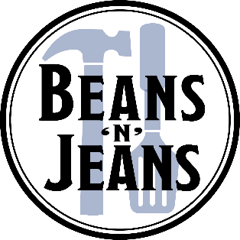
Auction Donor Form: Beans ‘n’ Jeans 2024
Donor Name/Logo: ___________________________________________________ (As you’d like your name presented for donor recognition online and the event program.
Email logo to habitat@palousehabitat.org to be included in online recognition.)
Contact Name:____________________________________________________
Address:_________________________________________________________
Email:_________________________________ Social Media @ # tags:_______________
Phone:___________________________ Website:__________________________
Item donated (1-2 sentences for online description):________________________
________________________________________________________________
________________________________________________________________
Key features to highlight in online description: ___________________________
_________________________________________________________________
Restrictions/Expirations: ____________________________________________
Approx. Retail Value:________________________________________________
Please contact the office for item & form pick up, or mail or deliver the item before
March 15, 2024. Thank you for supporting Palouse Habitat for Humanity!
PO Box 3054 or 306 N. Main Street, Moscow, ID 83843; 208-883-8502 habitat@palousehabitat.org

